

**Department of Computer Science and Engineering**

**Year: 2016-2020**

**JAVA PROJECT**

**TOUR AND TRAVELS**

**Submitted To: Submitted By:**

Rajshree Shrivastav Anchal Malik

16BCS1828

CSE-9

Group-B

**ABSTRACT**

The purpose of this project is to provide the different tours to the Customers want to visit.

Customers can choose the different type of Sources and Destination, Dates of Journey, Fairs for the tours, they can select whether they want to visit national or international tour and they can also select the Hotels. The customers can also Book tickets with all these facilities available and after that customer can check the details of the Ticket by option of Ticket Details.

This Tours and Travel Management System will be very helpful to the customers.

**TABLE OF CONTENTS:**

|  |  |  |
| --- | --- | --- |
| **Sr. No.** | **Topic** | **Page No.** |
| 1. | Acknowledgement | 4 |
| 2. | Project Introduction | 5 |
| 3. | Objective | 6 |
| 4. | Platform description | 7 |
| 5. | Software Requirement Analysis | 8 |
| 6. | Project Methodology | 9-16 |
| 7. | Snapshots | 17-19 |
| 8. | Conclusion | 20 |
| 9. | References | 21 |

**ACKNOWLEDGEMENT**

The success and final outcome of this project required a lot of guidance and assistance from many people and I am extremely privileged to have got this all along the completion of my project. All that I have done is only due to such supervision and assistance and I would not forget to thank them.

I respect and thank Ms. Rajshree Srivastava for providing me an opportunity to do the project work and giving us all support and guidance which made me complete the project duly.

I am thankful to and fortunate enough to get constant encouragement, support and guidance from all Teaching staffs of CSE DEPARTMENT which helped us in successfully completing our project work. Also, I would like to extend our sincere esteems to all staff in laboratory for their timely support.

**Anchal Malik**

**INTRODUCTION**

The Tours and Travel Management System is a web based

application. The main purpose of “Tours and Travels Management

System ” is to provide a convenient way for a customer to book

hotels, flight, train and bus for tour purposes. The objective of this

project is to develop a system that automates the processes and

activities of a travel agency. In this project, we will make an

easier task of searching places and for booking train, flight or bus. In

the present system a customer has to approach various agencies to

find details of places and to book tickets. This often requires a lot of

time and effort. We provide approach skills to critically examine how

a tourist visits and its ability to operate in an appropriate way when

dealing with the consequences of tourism, locally, regionally, and

nationally including visitor security and ecological influences. It is

tedious for a customer to plan a particular journey and have it

executed properly. The project ‘Tours and travels Management

System’ is developed to replace the currently existing system, which

helps in keeping records of the customer details of destination as well

as payment received.

**OBJECTIVES**

This application is develop to provide best travelling services to the

customers and travel agents. We have developed tours and travel

management system to provide a search platform where a tourist can

find their tour places according to their choices. This system also

helps to promote responsible and interesting tourism so that people

can enjoy their holidays at their favorable places. This system also

helps to develop tourism with different cultures so that they enrich the

tourism experience and build pride. We develop this system to create

and promote forms of tourism that provide healthy interaction

opportunities for tourists and locals and increase better understanding

of different cultures, customs, lifestyles, traditional knowledge

and believes. This system also provide a better way to connect with

various events. 

This system also gives tours related information like which places are

tourist attractions, cities, and provinces. Tourist can also get the Map

and navigation system and temperature and weather information.

Tourist can also book tours through our tours and travels management

system. This system also keeps a history of visited places of its users. 

**Platform Description**

|  |  |
| --- | --- |
| **NAME OF COMPONENT** | **SPECIFICATION** |
| **Operating system** | Window 10 (32-Bit) |
| **Developing Interface** | Eclipse |
| **Language** | Core Java |
| **Browser** | Chrome , Edge , etc |
| **Software Development Kit** | Java JDK 1.7 or above |

**Software Requirement Analysis**

**Software Requirements:-**

1. Java Eclipse

**Hardware Requirements:-**

1. Pentium
2. 2GB ram
3. 20GB hard disk

### 

### **Modules of Tour and Travels**

**Management System**

* **User Management**

a. Login.   
  
 b. User profile.   
  
 c. Update information.   
  
 d. Role based rights.

* **Administrator module :**

This module provides administrator related functionality like

from this module use can add route information, bus information,

train information, flight information, tour packages, travel

packages, bus seat details, etc. From this module Admin can view

daily, weekly and monthly report. This module is develop for

admin of the website and admin can add, delete, edit and view the

data related to places, travels, routes, bookings from this module.   
  
 a. Manage user information.   
   
 b. Update information.   
  
 c. Manage Trips.   
  
 d. Manage Transportation.   
  
 e. Manage hotel, Bookings.

* **Hotel Module:**  
  Details of the hotels in which the accommodation of the customer will be done during the tours. Details like availability of meals, station-pickup and drop facility and contact no. of the hotels are also provided to the customers on special request.   
    
   a. Registration (as user)   
    
   b. Registration (as Hotel)   
    
   c. Search
* **Transportation Module:**  
    
   a. Flight   
    
   b. Train   
    
   c. Bus
* **Package Modules:**  
    
  User can view different tour packages available for tourist. User can select any packages from this module he can also check the details of various travel agencies. A user can select any travel agency from this module.

* **Payment Module**:  
    
   a. pay Online payment   
    
   b. pay payment through Draft
* **Search Module**  
    
   search City wise hotels, flights, packages, bus, rails and events.
* **Reservations module:**  
    
  This module is for passengers where passenger can reserve the seats by making payment. Using this module user can book bus ticket or train ticket. From this module user can also book tickets or cancel previously booked tickets. The module maintains the details of all reservations made so far and allows administrator to either confirm or reject the bookings.   
  this portal and services to the administrator. Accordingly, the administrator can take various steps to act on the complaints and suggestions.
* **Tour Details:**  
    
    
  Details of different types of tours which includes tours like family tours, couple tours, general tours, date and time of departure and the fair of the tours etc are maintained. As the customer ask for the details of a particular tour, the tours and travel management system gives the details of the related place where tourist wants to go and the date and time of the tour, no. of seats available of that particular tour, fair of the tour, details of discount on a particular tour package if any. Details of the pick-up facilities and the drop facilities are also maintained if any.

**Code**

package project;

import java.awt.*;

import java.awt.event.ActionEvent;

import java.awt.event.ActionListener;

import javax.swing.JOptionPane;

import java.awt.event.WindowEvent;

import java.awt.event.WindowAdapter;

public class Demo {

public static void main(String[] args) {

Frame f = new Frame("RA Airline");

f.setSize(700,700);

f.setLayout(null);

Button b1 = new Button("LOG IN");

b1.setBounds(200, 100, 170, 30);

b1.addActionListener(new ActionListener(){

        public void actionPerformed(ActionEvent e){

         Frame f1 = new Frame("Log In Page");

         Label l7=new Label("modes of transport");

         Label l1 = new Label("UserName");

         l1.setBounds(100,100,100,30);

          TextField t1 = new TextField();

             t1.setBounds(230, 100, 150, 30);

             Label l2 = new Label("Password");

         l2.setBounds(100,150,100,30);

          TextField t2 = new TextField();

          t2.setEchoChar('*');

             t2.setBounds(230, 150, 150, 30);

         f1.add(l1); f1.add(t1); f1.add(l2); f1.add(t2);

         Button b1 = new Button("Submit");

     b1.setBounds(150, 200, 170, 30);

     b1.addActionListener(new ActionListener() {

     public void actionPerformed(ActionEvent e) {

     if(t1.getText().equals("123") && t2.getText().equals("123"))

     {

     Frame f = new Frame("Book your Ticket");

     Label l7=new Label("Modes Of Transport");

     l7.setBounds(100,150,100,30);

     Label l1 = new Label("NAME");

     l1.setBounds(100,50,100,30);

     Label l2 = new Label("Select the Class");

     l2.setBounds(100,100,100,30);

     Label l8=new Label("slct national/international");

     l8.setBounds(100,200,100,30);

     Label l3 = new Label("Source");

     l3.setBounds(100,250,100,30);

     Label l4 = new Label("Destination");

     l4.setBounds(100,300,100,30);

     Label l9=new Label("fair price");

     l9.setBounds(100,350,100,30);

     Label l5 = new Label("Date of journey");

     l5.setBounds(100,400,100,30);

     Label l10=new Label("hotel");

     l10.setBounds(100,450,100,30);

     f.add(l1); f.add(l2); f.add(l3); f.add(l4); f.add(l5); f.add(l7); f.add(l8);f.add(l9);

     f.add(l10);

     //Background color

     f.setBackground(Color.lightGray);

     Choice c = new Choice();

     c.add("NOne");

     c.add("Business");

     c.add("Economy");

     c.setBounds(230,100 , 150, 30);

     f.add(c);

     Choice c1=new Choice();

     c1.add("BUS");

     c1.add("TRAIN");

     c1.add("FLIGHT");

     c1.setBounds(230,150,150,30);

     f.add(c1);

     Choice c2=new Choice();

     c2.add("NATIONAL");

     c2.add("INTERNATIONAL");

     c2.setBounds(230,200,150,30);

     f.add(c2);

     Choice c3=new Choice();

     c3.add("Rs 200");

     c3.add("Rs 500");

     c3.add("Rs 850");

     c3.add("Rs 1000");

     c3.add("RS 1500");

     c3.add("Rs 2000");

     c3.setBounds(230,350,150,30);

     f.add(c3);

     Choice c4=new Choice();

     c4.add("TAJ HOTEL");

     c4.add("JW MARRIOT");

     c4.add("HAYAT");

     c4.setBounds(230,450,150,30);

     f.add(c4);

     //SOURCE

     Choice d = new Choice();

     d.add("DEL:Delhi");

     d.add("BOM:Mumbai");

     d.add("LKO:Lucknow");

     d.add("IXC:Chandigarh");

     d.add("BLR:Bangalore");

     d.add("HYD:Hyderabad");

     d.add("JHARKHAND:ranchi");

     d.add("KOL:kolkata");

     d.add("GUJ:ahemdabad");

     d.setBounds(230,250 , 150, 30);

     f.add(d);

     //DESTINATION

     Choice ch = new Choice();

     ch.add("JFK/KJFK:New York");

     ch.add("PEK/ZBAA:Beijing");

     ch.add("DXB/OMDB:Dubai");

     ch.add("LHR/EGLL:London");

     ch.add("SIN/WSSS:Singapore");

     ch.add("CDG:Paris");

     ch.add("AMERICA:newjersey");

     ch.add("AFRICA:nigeria");

     ch.add("AUSTRALIA:perth");

     ch.setBounds(230,300 , 150, 30);

     f.add(ch);

         TextField t1 = new TextField();

         t1.setBounds(230, 50, 150, 30);

         TextField t5 = new TextField();

         t5.setBounds(230, 400, 150, 30);

         f.add(t1);  f.add(t5);

         //BUTTON

         Button b = new Button("Book Ticket");

         b.setBounds(100,500,280,30);

         b.addActionListener(new ActionListener(){

             public void actionPerformed(ActionEvent e){

              Frame f1 = new Frame("Ticket Details");

              Label l1 = new Label("NAME:");

              l1.setBounds(100,50,50,30);

               Label w1 = new Label(t1.getText());

                  w1.setBounds(180, 50, 150, 30);

                  Label l2 = new Label("CLASS:");

              l2.setBounds(90,100,50,30);

               Label w2 = new Label(c.getSelectedItem());

                  w2.setBounds(180, 100, 150, 30);

                  Label l3 = new Label("SOURCE:");

              l3.setBounds(80,150,60,40);

               Label w3 = new Label(d.getSelectedItem());

                  w3.setBounds(180, 150, 150, 30);

                  Label l4 = new Label("DESTINATION:");

              l4.setBounds(70,200,100,30);

               Label w4 = new Label(ch.getSelectedItem());

                  w4.setBounds(180, 200, 150, 30);

                  Label l5 = new Label("DATE OF JOURNEY:");

              l5.setBounds(50,250,120,30);

               Label w5 = new Label(t5.getText());

                  w5.setBounds(180, 250, 150, 30);

              Label l7=new Label("Modes Of Transport");

              l7.setBounds(40,300,120,30);

               Label w7 = new Label(c1.getSelectedItem());

               w7.setBounds(180, 300, 150, 30);

               Label l8=new Label("slct national/international");

               l8.setBounds(30, 350, 120, 30);

               Label w8 = new Label(c2.getSelectedItem());

               w8.setBounds(180, 350 ,150, 30);

               Label l9=new Label("fair price");

               l9.setBounds(20, 400, 120, 30);

               Label w9 = new Label(c3.getSelectedItem());

               w9.setBounds(180, 400, 150, 30);

               Label l10=new Label("hotel");

               l10.setBounds(10,450,120,30);

               Label w10 = new Label(c4.getSelectedItem());

               w10.setBounds(180,450,150,30);

    f1.add(l1); f1.add(w1);  f1.add(l2); f1.add(w2);  f1.add(l3); f1.add(w3);  f1.add(l4); f1.add(w4);  f1.add(l5); f1.add(w5);

       f1.add(l7);f1.add(w7);f1.add(l8);f1.add(w8);   f1.add(l9);f1.add(w9);

       f1.add(l10);f1.add(w10);

                              f1.setSize(700,700);

                  f1.setLayout(null);

                  f1.setVisible(true);

             }

             });

         f.add(b);

         f.setSize(400,400);

         f.setLayout(null);

         f.setVisible(true);

     }

                 else

                  JOptionPane.showMessageDialog(null,

                                "Please, Enter Correct Details",

                                "ERROR!",

                                JOptionPane.WARNING_MESSAGE);

     }

     });

     f1.add(b1);

           f1.setSize(500,500);

             f1.setLayout(null);

             f1.setVisible(true);

        }

        });

f.add(b1);

f.setLayout(null);

f.setVisible(true);

f.addWindowListener(new WindowAdapter(){

            public void windowClosing(WindowEvent we)

        {

                System.exit(0);

             }

        });

}

}

**SNAPSHOTS**

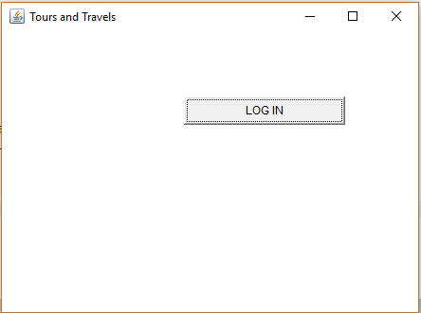

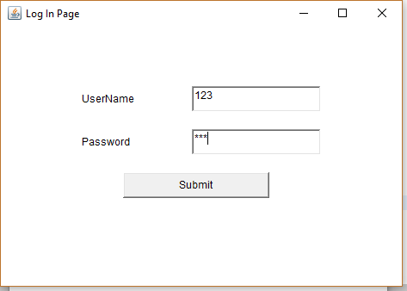

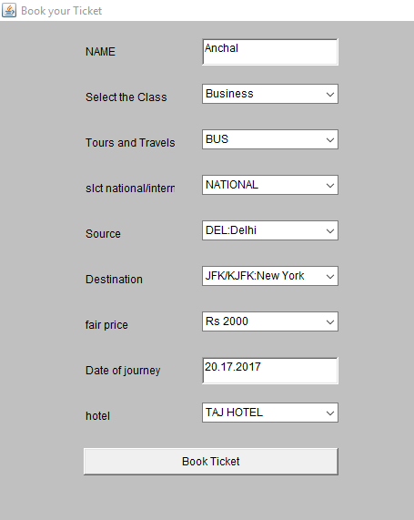

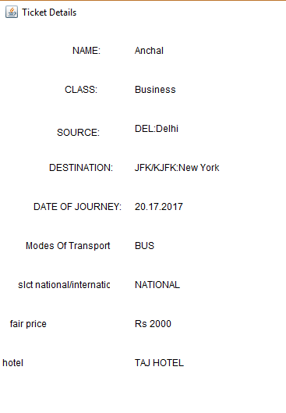

**CONCLUSION**

This report introduced Tours for you. We presented information about National or International tour, Mode of Transport, Source and Destination, Dates of Journey, Fair for the tour, Hotels available there. This innovative idea will help us to develop our the future. This would help the customers to book their tickets

online by opening the site and booking option. They can choose their beloved destinations according to their need. So at the end it would be a great system which would help each and every person in its life.

**REFRENCES**

**Books**

* Oreily Learning Android
* Apress Beginning Android
* Wrox Beginning Android 4

**Refrences**

* http://www.javapoint.com/tutorals/
* <http://www.vogella.com/tutorials/>